PDP GUIDE FOR RESEARCH STUDENT SUPERVISORS

‘PDP is ‘a structured and supported process undertaken by an individual to reflect upon their own learning, performance and/or achievement and to plan for their personal, educational and career development’ (QAA 2001 emphasis added). Personal/Professional Development Planning (PDP) is a process already present in most PhD supervision and study practices.

There are some key features of PDP:

- PDP is an ongoing process. It is not carried out at a single point in time nor is it a single document.
- PDP provides postgraduate research students with the opportunity to plan, reflect on and record their progress, development and achievements.
- PDP formalises good practice in working for and supervising a research degree.
- PDP is a structured and supported process. The student is provided with structure and support by:
  - The Skills Analysis Questionnaire
  - The Postgraduate Skills Training Programme (PSTP)
  - Records of meetings with their supervisor(s)
  - Training plans
  - Formal reviews – at 3 month, differentiation, and annual monitoring
  - Records and evidence of their achievements
  - Their evaluation and reflection on their progress, achievements and skills
  - Their research diary or log book or project management file
  - Support comes from their supervisor(s), their colleagues and other staff in the School, the Postgraduate Office, the Careers and Counselling Services
- PDP is a continuous cycle of:
  - Self-assessment and evaluation
  - Identification of needs and goals
  - Planning a course of action to meet these needs and goals
  - Carrying out their action plan and recording their achievements
  - Reflecting on the outcomes and evaluating their progress, which should then reveal new needs and goals (Figure 1)

REVIEWING

DOING

PLANNING

REFLECTING

PDP

Figure 1

The PDP cycle

- PDP requires a series of documents. Some of these should be revisited regularly by the student individually and sometimes with you. The documents belong variously to them, you and the University.
- In addition to the benefits listed below, PDP supports the timely completion and submission of their thesis.

Benefits to the student

The benefits to the student if they participate in PDP are that when they have completed their research programme they will have:

- engaged in a holistic approach to their educational, career and personal development
- become more effective in monitoring and reviewing their progress
- demonstrated that they can access and use the aids and tools provided by Queen’s to help them reflect on their own learning and achievements and plan for their own personal, educational and career development
- prioritised development goals throughout their research programme and identified opportunities to improve perceived weaknesses and enhance their strengths
- created a record of their skills, qualities and achievements which they can use when applying for future employment or furthering their research career
- become a more effective, independent and confident self-directed researcher and learner

PDP PORTFOLIO

The student’s PDP portfolio is their way of maintaining the PDP records that they generate in the course of their time at Queen’s. How they maintain their portfolio is up to them. They might want to keep a paper record, a record in MS WORD or they might want to make use of an on-line tool. There are a number of electronic tools that they can use individually or in combination – Postgraduate Skills Training Programme (PSTP), PDP On-line and MS Outlook Tasks. The first two are accessed via Queen’s On Line (QOL) (Figure 2) and all Postgraduate Research students have access to MS Outlook. PDP Online has a page for each School to post information, key dates, news and regulations etc for postgraduate research students.

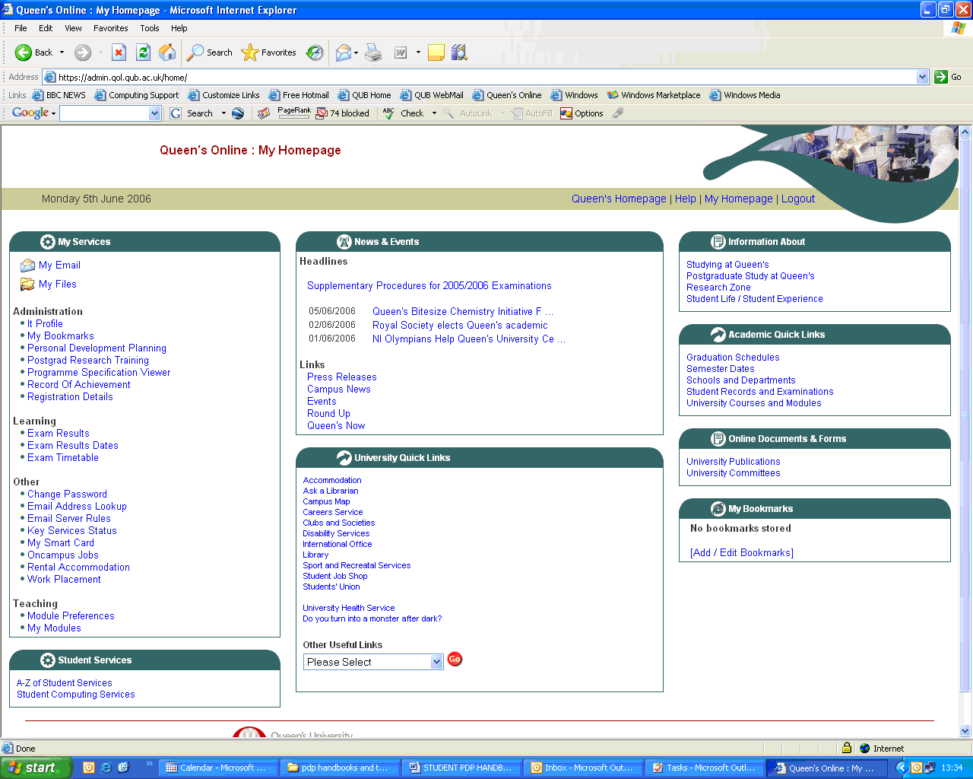

Figure 2

A research student’s Queen’s Online Homepage for PSTP and PDP Online

POSTGRADUATE SKILLS TRAINING PROGRAMME

The Postgraduate Office provides opportunities for students to undertake skills training. The training opportunities offered are based on the UK Research Councils Joint Skills Statement (Appendix 1). Depending on the nature of the project the courses offered will provide students with generic and also project specific skills. To decide which courses to undertake a Skills Analysis Questionnaire (SAQ) is provided (Figure 3).

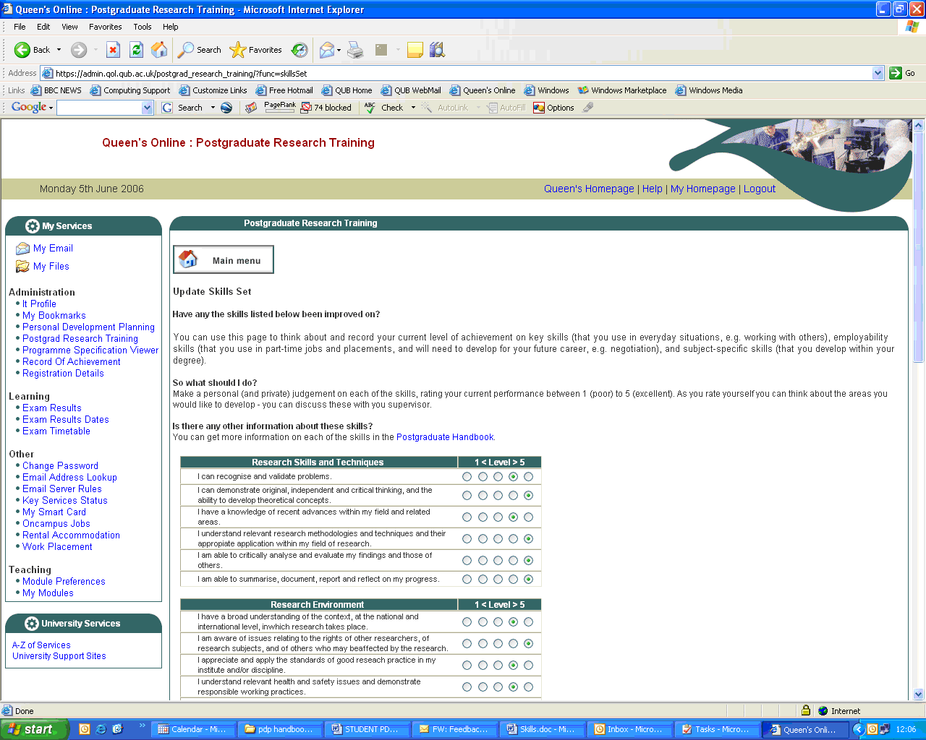
Figure 3

A student’s SAQ page

It is good practice for students to record the evidence base of their self assessment (Table 1).

Table 1
Skills | Score 1-5* | Best yet evidence
Research skills and techniques – to be able to demonstrate:
The ability to recognise and validate problems |  | A valid research proposal
A knowledge of recent advances within one’s field and in related areas |  | Supervisor feedback on 3 differentiation report.
An understanding of relevant research methodologies and techniques and their appropriate application within one’s research field |  | A research proposal
The ability to critically analyse and evaluate one’s findings and those of others |  | Examples of data analysis

Examples of recording evidence of skills

Students should complete the SAQ honestly and discuss the results with you. You will be able to advise which courses are appropriate and timely to meet the student’s needs. Students should revisit the SAQ at least once a year and update their training needs.

PDP and feedback

An important part of PDP is that students take account of the feedback they are given during the course of their research. Feedback can come from a variety of individuals or groups:

- you
- their research student colleagues
- other staff in the research cluster, subject area or School
- research students and staff from other institutions or organisations

and in a variety of contexts:

- during formal supervisions
- during informal discussions, i.e. over coffee, in the lab or in the field etc
- written feedback on drafts of chapters, reports, monitoring reports
- during and following seminars
- at workshops and PSTP courses
- at conferences

Students need to use that feedback to review what they have done and reflect and plan what to do in the future.

When to do PDP

There are many points in time during their research career that provide good opportunities for students to engage with PDP (Table 2).

Table 2
Occasion | When
Induction | Weeks 1 - 4
3 month initial review | ca 12 weeks
Differentiation | 9-12 months
Annual Review | June-August year 1
Annual Review | June-August year 2
Monthly/interim reports | Variable
Supervision meetings | At least 6 per year
Attending seminar series | Variable
Presenting a seminar | Variable
Research cluster meetings | Variable
Attending a conference | Variable
Presenting a paper at a conference | Variable
Organising a seminar series or conference | Variable
Undertaking training via the PSTP | Variable
Following a subject specific module(s) | Variable
Teaching or demonstrating | Variable
Working with industry or companies | Variable
Writing papers/chapters | Variable
Others | Variable
Examination preparation | ca 6 weeks following submission

Examples of opportunities for PDP for Postgraduate Research students

Personal/Career Planning

Whilst most of the student’s PDP will centre on their research project, its academic needs, and project and generic skills needs, they will also have personal and career goals that they will want to fulfil during their time at Queen’s. They can build these into their PDP cycle. The Counselling Service and the Careers Service provide Personal Effectiveness and Career Management courses as part of the PSTP. Indeed, the Joint Skills Statement encourages students to develop their skills in theses areas and issues concerning these may arise during the opportunities for PDP identified in Table 2. These services will also provide students with opportunities for individual assistance in personal and career planning which they can build into their PDP.

Appendix 1
Joint Skills Statement from the Research Councils

This statement sets out the skills that postgraduate research students would be expected to have or develop during their PhD. These skills may already exist for some students or developed during the course of their research. It is expected that different training mechanisms will be used in the development of these skills - including formal training courses, seminars, conferences, supervisor guidance and coaching, School support and informal opportunities.

A) Research Skills and Techniques –

To be able to demonstrate:
- the ability to recognise and validate problems
- original, independent and critical thinking, and the ability to develop theoretical concepts
- a knowledge of recent advances within one’s field and in related areas
- an understanding of relevant research methodologies and techniques and their appropriate application within one’s research field
- the ability to critically analyse and evaluate one’s findings and those of others
- an ability to summarise, document, report and reflect on progress

B) Research Environment –

To be able to:
- show a broad understanding of the context, at the national and international level, in which research takes place
- demonstrate awareness of issues relating to the rights of other researchers, of research subjects, and of others who may be affected by the research, e.g. confidentiality, ethical issues, attribution, copyright, malpractice, ownership of data and the requirements of the Data Protection Act
- understand relevant health and safety issues and demonstrate responsible working practices
- understand the processes for funding and evaluation of research
- justify the principles and experimental techniques used in one’s own research
- understand the process of academic or commercial exploitation of research results

C) Research Management –

To be able to:
- apply effective project management through the setting of research goals, intermediate milestones and prioritisation of activities
- design and execute systems for the acquisition and collation of information through the effective use of appropriate resources and equipment
- identify and access appropriate bibliographical resources, archives, and other sources of relevant information
- use information technology appropriately for database management, recording and presenting information

D) Personal Effectiveness –

To be able to:
- demonstrate a willingness and ability to learn and acquire knowledge
- be creative, innovative and original in one's approach to research
- demonstrate flexibility and open-mindedness
- demonstrate self-awareness and the ability to identify own training needs
- demonstrate self-discipline, motivation, and thoroughness
- recognise boundaries and draw upon/use sources of support as appropriate
- show initiative, work independently and be self-reliant

E) Communication Skills –

To be able to:
- write clearly and in a style appropriate to purpose, e.g. progress reports, published documents, thesis
- construct coherent arguments and articulate ideas clearly to a range of audiences, formally and informally through a variety of techniques
- constructively defend research outcomes at seminars and viva examination
- effectively support the learning of others when involved in teaching, mentoring or demonstrating activities

F) Networking and Team working –

To be able to:
1. Develop and maintain co-operative networks and working relationships with supervisors, colleagues and peers, within the institution and the wider research community
2. Understand one's behaviours and impact on others when working in and contributing to the success of formal and informal teams
3. Listen, give and receive feedback and respond perceptively to others

G) Career Management –

To be able to:
- appreciate the need for and show commitment to continued professional development take ownership for and manage one's career progression, set realistic and achievable career goals, and identify and develop ways to improve employability
- demonstrate an insight into the transferable nature of research skills to other work environments and the range of career opportunities within and outside academia
- present one's skills, personal attributes and experiences through effective CVs, applications and interviews

